Sculptor
Solids of Revolution

Sculptor creates new models using lines and splines by rotating the spline curve or lines around the vertical through 360 degrees where the X axis equals 0.

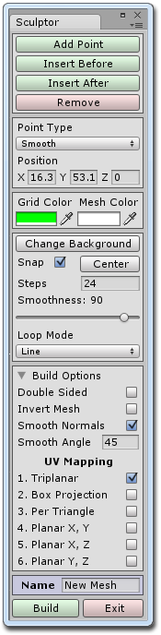
Starting Sculptor

To start using Sculptor click on the Window menu item, scroll down to the Sculptor item and then click on Open Window.

When the window opens you will notice that a new object called Sculptor has been added to the hierarchy. This item is the green wireframe cube that appeared in the scene view window. You can move it around and rotate it like a normal object. The wireframe mesh at the center of the green cube is a preview of a sculpture which has been created for you.

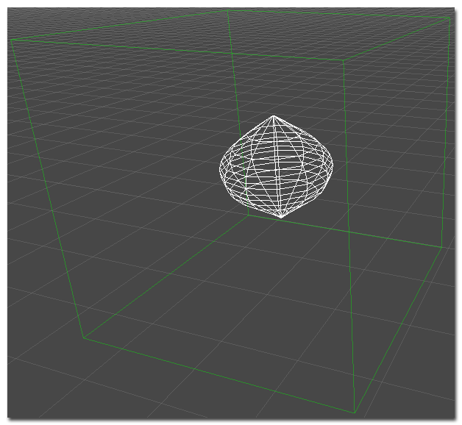

The Sculptor Window

The sculptor window contains two main areas. To the right is the menu and to the left is the working area. This window is overlaid with a grid which represents the unit scale used within the Unity scene. When you resize the window the grid will automatically adjust and you can zoom in and out of the grid by using the mouse scroll wheel. You can also move the grid around by left clicking and dragging anywhere on the background.
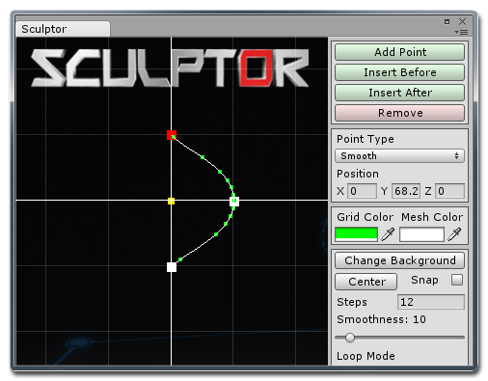
The two white lines that intersect at the center are the zero points on the X and Y axis and the yellow square at the center is just a reminder of where the pivot point will be positioned in the final mesh.

You will notice that there is already a spline added to the window which contains three control points, shown as red and white squares. If the control point is colored red then that is the active control point and its position and point type is displayed in the menu. When you move the mouse cursor over a control point the cursor will change to a hand and you can left click to drag the point to a new position. The wireframe mesh in the scene view will update to show you a preview of what the final mesh will look like.

Along the length of the spline are smaller green squares that indicate where the horizontal edges of the mesh are located.

Adding and Removing Control Points

Adding points is as easy as clicking on the top three buttons from the menu. The first button will append a control point to the end of the spline while the other two buttons will insert a control point before or after the currently selected point.

By default all new control points will be a smooth type. You can change the points to another type by first selecting a point and then selecting a new type from the drop down list in the menu. A point set to be a corner will behave like a straight line while the Bezier and Bezier Corner types give you more control over how the spline curves close to that point. At any time you can manually enter new values for the control points position in the menu.
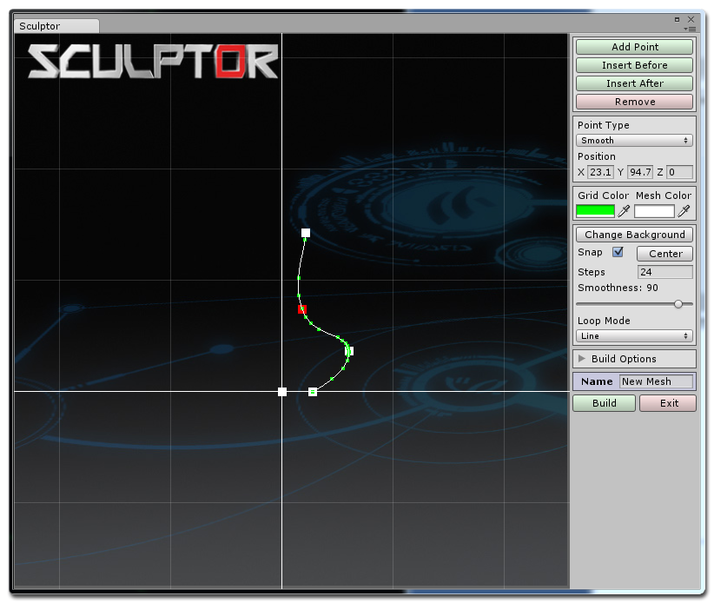
If you find that the curve is bunching up when points are too close together try changing the point to a Bezier type and tweak the X and Y values to shorten or lengthen the curve.

Grid and Mesh Colors

Just below the control point settings on the menu are two color fields that allow you to change the colors of the cube and preview mesh in the scene view. This can come in handy if the scene has similar colors which make it hard to see the preview mesh.

Changing the Background Image

The Sculptor title and background are simply an image that is located in the Resources folder and you can change this with your own image. You can also change this image temporarily if you want to trace a picture of a real world object. To do so, simply click on the Change Background button from the menu and select a JPG or PNG file using the dialog window that opens. When the new image is loaded it is placed at the top left of the window and you can move it to a new position by holding the middle mouse button down while dragging the image.

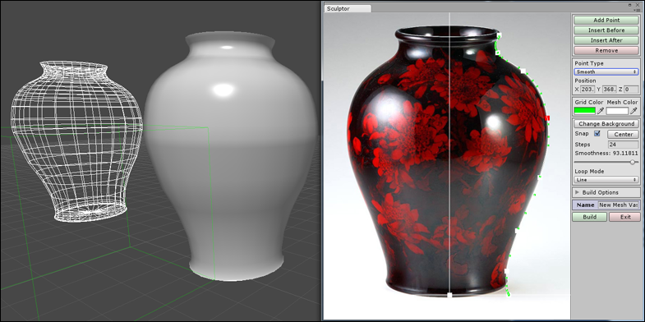
Snap to Grid

It is not recommended to move the control points to the left side of the vertical line as the final meshes will be inverted or have other problems. But there may be cases where it produces a nice effect so I have not restricted the points from crossing this line. More often than not you will probably want to have the points line up with this center line so you can toggle the Snap feature on to make the control points snap to the main vertical or horizontal lines. To move them off the lines again just move the mouse faster when dragging them.

Center Button
This button is convenient if you need to quickly return to the center of the grid.

Steps and Smoothness
To increase the number of horizontal edges, and therefore its smoothness, you can adjust the slider from the menu. Changing the number of steps in the rotation creates more or less vertical edges. More edges will look smoother or for an angular look you can reduce. One warning though, the program is still in beta and has not been thoroughly optimized yet. If you increase the steps or smoothness by a lot then it could take a very long time to calculate the new mesh.

Loop Mode

By default the program is set to work with splines and lines that are not looped but you can get some great shapes by changing the program to work with looped splines. A looped spline with 3 or 4 steps can produce some nice geometric shapes.

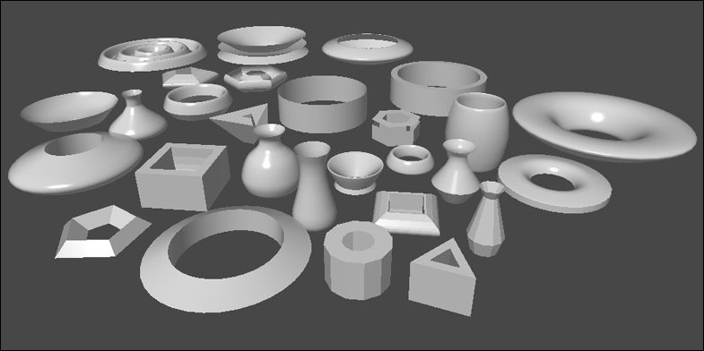
Build Options

When you open the Build Options foldout you will see that only the option for a smooth mesh is selected. You can also set the final mesh to be inverted, double sided or have a faceted appearance by turning these options on or off before clicking on the Build button.

UV mapping

The choice of UV mapping depends on the type of mesh being made. Most of the time you will probably want to stick with the default triplanar mapping but for flat shapes you might want to try a planar type.

Building the Mesh

When you have everything positioned where you want and you have set the build options you can go ahead and create the final mesh by clicking on the Build button. The mesh file for the finished sculpture will be stored in the meshes folder.

Prefabs

Prefab objects are automatically created by default and placed in the main folder in a subfolder called Prefabs. You can change this behavior by un-ticking the first check box in the list.

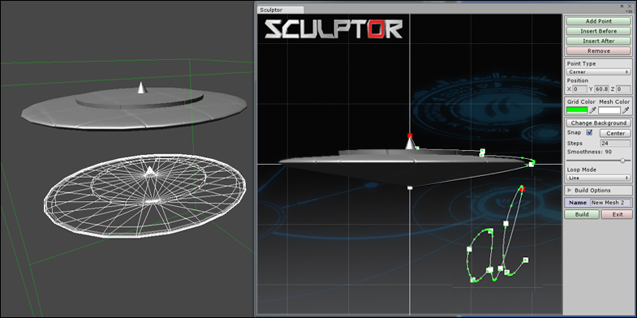

To learn more about Sculptor and to view the tutorial videos you can visit
MeshMaker.com

